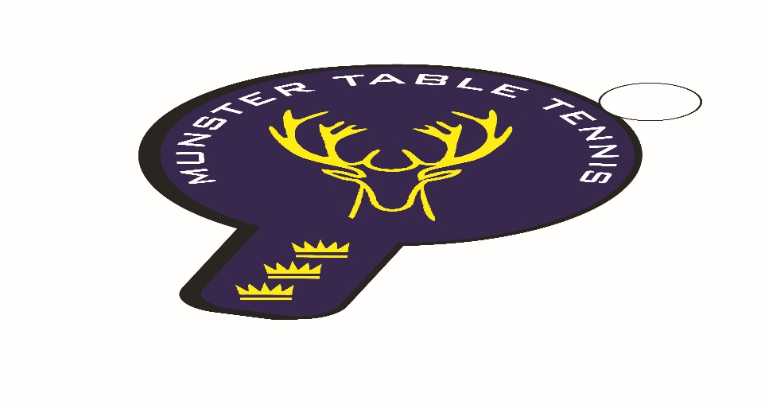
Munster Ranking Competition No 4 – 03 March 2024
Competition Report
A total of 65 entries were received for the fourth Munster ranking competition of the 2023/24 season, which was held in Knocknaheeny, Cork City. We had players from Cork, Kerry and Waterford with 5 different clubs contributing players. The following categories were offered – U/11,U/13, U/15, Para, Veterans and Senior Divisions 1 and 2. Once again, and this has been a feature of ranking competitions this season, Division 2 was a mixed ability competition. Division 1 was limited to the top 16 players in order to create tighter matches.
Piotr Stankewicz , South Coast, prevailed in the Senior 1 Division defeating Kevin O’Keeffe, Leeside, in the final. Leeside’s Chetan Rai took the Division 1 Plate title by beating Killarney’s Radek Zbik. In Division 2 it was a win for Johnny Biehl, Leeside, with Romeo Facon, South Coast, coming second. In the Division 2 Plate final Leeside’s Sean Buckley defeated Patrick McCormick of Beech Hill. In the Veterans, Piotr Stankiewicz of South Coast completed a double of titles with victory over Killarney’s Anthony Redmond, Killarney. The Veterans Plate final Catherine Morrissey of Waterford beat Evaldas Pusinskas of Leeside.
In the Para competition, victory went to Kevin O’Callaghan of Beech Hill in a round robin event. The U/11 Girls competition was won by Samanta Pusinkas of Leeside also in a round robin event. The U/13 Boys was won by Florian Lotkowski of South Coast in a round robin event, while the U/15 Boys title went to Sasha Collins of Leeside, again in a round robin format. The stand out performance on the days was that of Piotr Stankewicz for his wins in both the Senior and Veterans, while Leeside and South Coast won three divisions each. The results are as follows:
U/11 Girls
1st: Samanta Pusinskas – Leeside
2nd: Emma O’Callaghan – Beech Hill
3rd: Nicki Konya - Leeside
U/13 Boys
1st: Florian Lotkowski – South Coast
2nd: Olaf Chmielewski – Killarney
3rd: Attila Magyar Jnr – South Coast
3rd:
U/15 Boys
1st: Sasha Collins – Leeside
2nd: Sean Buckley – Leeside
3rd: Kevin O’Callaghan – Beech Hill
Veterans
1st: Piotr Stankewicz – South Coast
2nd: Anthony Redmond – Killarney
Joint 3rd: Philip Shaw & Nikolay Genov – Beech Hill

Para
1st: Kevin O’Callaghan – Beech Hill
2nd: Patrick McCormick – Beech Hill
Joint 3rd: Niamh Cafferkey & Aoife Kelly – Beech Hill
Senior Division 1
Ist: Piotr Stankewicz – South Coast
2nd: Kevin O’Keeffe – Leeside
Joint 3rd: Anthony Redmond – Killarney & Sean Loughnane – South Coast
Senior Division 2
1st:Johnny Biehl– Leeside
2nd: Romeo Facon – South Coast
Joint 3rd: Catherine Morrissey – Waterford & Piotr Sawecki - Leeside

