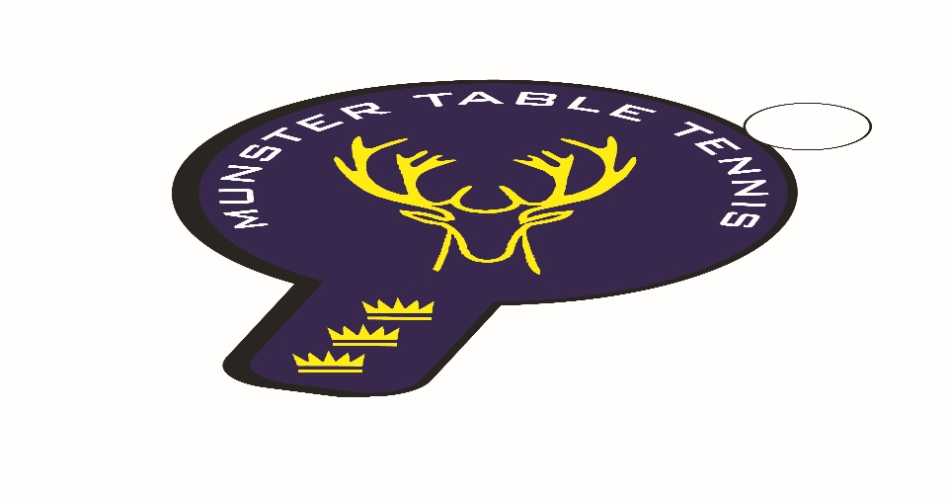
Munster Ranking Competition No 3 – 18 February 2024
Competition Report
A total of 63 entries were received for the third Munster ranking competition of the 2023/24 season, which was held in Kinsale, Co Cork. We had players from Cork and Kerry with 5 different clubs contributing players. While it was encouraging to see more new faces for both the Senior and Veterans competitions, the big positive was that we were able to offer an U/11 Girls competition on this occasion. The following categories were offered – U/11,U/13, U/15, Para, Veterans and Senior Divisions 1 and 2.
Sean Loughnane, South Coast, once again prevailed in the Senior 1 Division defeating his brother, Ben, in the final. South Coast’s Michael Lotkowski took the Division 1 Plate title by beating Leeside’s Alessandra Fadda. In Division 2 it was a one, two for Leeside with Conall Conroy beating Caoimhe Deane in the final, while Junior player, Sasha Collins, Leeside, took the Division 2 Plate final by beating Attila Magyar Jnr, South Coast. In the Veterans, Anthony Redmond, Killarney, beat Philip Shaw, Beech Hill in the final, while in the Veterans Plate final, Marius Chmielewski, Killarney prevailed over Attila Magyar of South Coast.
In the Para competition, victory went to Patrick McCormick of Beech Hill beating fellow club man, Nicolas O’Brien in the final. The U/11 Girls competition was won by Samanta Pusinkas of Leeside in a round robin event. The U/13 Boys was won by Attilla Magyar Jnr of South Coast defeating Theo Farkas, unattached, in the final, while Stepan Suprun, from our Ukrainian community in Cork, defeated Akos, South Coast, in the U/13 Boys Plate final. Finally, the U/15 Boys title went to Conall Conroy of Leeside in another round robin event. On the inter club front, Leeside shaded best club with 3 firsts against South Coast with 2 firsts and young Conall Conroy of Leeside was the most successful individual player winning both the Division 2 and Under 15 Boys titles. The results are as follows:
U/11 Girls
1st: Samanta Pusinskas – Leeside
2nd: Emma O’Callaghan – Beech Hill
3rd: Nicki Konya - Leeside
U/13 Boys
1st: Attila Magyar Jnr – South Coast
2nd: Theo Farkas – Unattached
Joint 3rd: Olaf Chmielewski – Killarney/Florian Lotkowski – South Coast
U/15 Boys
1st: Conall Conroy – Leeside
2nd: Kevin O’Callaghan – Beech Hill
3rd: Sasha Collins - Leeside
Veterans
1st: Anthony Redmond - Killarney
2nd: Philip Shaw – Beech Hill
Joint 3rd: Alessandra Fadda – Leeside/Piotr Stankiewicz - South Coast

Para
1st: Patrick McCormick – Beech Hill
2nd: Nicolas O’Brien – Beech Hill
Joint 3rd: Patrick Sweeney/Aoife Kelly – Beech Hill
Senior Division 1
Ist: Sean Loughnane – South Coast
2nd: Ben Loughnane – South Coast
Joint 3rd: Kevin O’Keeffe – Leeside/Piotr Stankiewicz – South Coast
Senior Division 2
1st:Conall Conroy– Leeside
2nd: Caoimhe Deane - Leeside
Joint 3rd: Kasper Darnowski - Leeside /Patrick McCormick – Beech Hill

