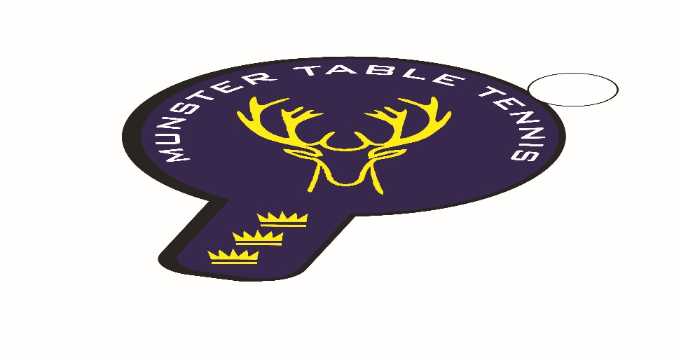
Munster Ranking Competition No 2 - 03 December 2023
Competition Report
A total of 56 entries were received for the second Munster ranking competition of the 2023/24 season, which was held in Knocknaheeny, Cork City. We had players from 3 counties – Cork, Kerry and Waterford – with 5 different clubs contributing players. It was particularly encouraging to see lots of new faces for both the Senior and Veterans competitions. particularly Natalya from Ballinskelligs, Co Kerry. The following categories were offered – U/13, U/15, Para, Veterans and Senior Divisions 1 and 2.
Sean Loughnane, South Coast, once again prevailed in the Senior 1 Division by beating Philip Shaw, Beech Hill, in the final. Leeside’s Chetan Rai took the Division 1 Plate title by beating Killarney’s Mariusz Chmielewski. In Division 2 Marcel Past of UCC beat Kasper Darnowski of Leeside in the final, while Junior player, Conall Conroy, Leeside, took the Division 2 Plate final by beating fellow club man, Frank Konya. In the Veterans, in a reverse of the previous ranking competition result, Piotr Stankiewicz of South Coast took the title in beating Philip Shaw, Beech Hill, in the final. Gary Mahoney, Leeside, won the Veterans’ Plate beating newcomer, Evhenii Koshelev, unattached.
In the Para competition, victory went to Nicolas O’Brien, Beech Hill defeating Niamh Cafferkey, also Beech Hill, in the final. The Para Plate went to Marian Collins, Beech Hill, who defeated fellow club player, Conor Moynihan. In the U/15 Group, overall victory again went to the up-and-coming Conall Conroy, Leeside, with Sasha Collins, also of Leeside in second place. South Coast’s Joshua Murphy won the U/13 final with Florian Lotkowski, also South Coast, runner up. Overall, club honours are shared between Leeside and South Coast with two firsts each. The results are as follows:
U/13
1st: Joshua Murphy – South Coast
2nd: Florian Lotkowski – South Coast
3rd: Theo Farkas - Unattached
U/15
1st: Conall Conroy – Leeside
2nd: Sasha Collins - Leeside
3rd: Sean Buckley - Leeside
Veterans
1st: Piotr Stankiewicz - Leeside
2nd: Philip Shaw – Beech Hill
Joint 3rd: Alessandra Fadda – Leeside/Lehel Szabd - Unattached
Para
1st: Nicolas O’Brien – Beech Hill
2nd: Niamh Cafferkey – Beech Hill
Joint 3rd: Patrick Sweeney/James Carroll – Beech Hill

Senior Division 1
Ist: Sean Loughnane – South Coast
2nd: Philip Shaw – Beech Hill
Joint 3rd: Ben Loughnane – South Coast/Jatin Jaitly - Leeside
Senior Division 2
1st: Marcel Past – UCC
2nd: Kasper Darnowski - Leeside
Joint 3rd: Robert Metcalfe - Leeside /Laura O’Keeffe - UCC

