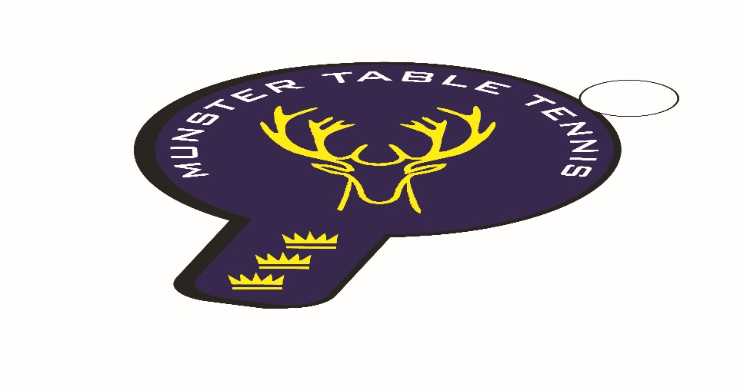
Munster Ranking Competition No 1 -19 November 2023
Competition Report
A total of 66 entries were received for the first Munster ranking competition of the 2023/24 season, which was held in Knocknaheeny, Cork City. We had players from 4 counties – Cork, Kerry, Limerick and Waterford – with 6 different clubs contributing players. It was particularly encouraging to see UL players back in competition again. The following categories were offered – U/13, U/15, Para, Veterans and Senior Divisions 1 and 2.
Sean Loughnane, South Coast, prevailed in the Senior 1 Division by beating Anthony Redmond, Killarney, in the final. UCC’s Konstantine Knuferman took the Division 1 Plate title by beating Killarney’s Danny Szabat. In Division 2 Attila Magyar Snr, South Coast, beat young Caoimhe Deane of Leeside in the final, while Junior player, Patrick McCormick of Beech Hill took the Division 2 Plate final by beating Shuming Huang of UL. In the Veterans the evergreen Philip Shaw, Beech Hill, took the title in beating Piotr Stankiewicz, Leeside, in the final. In the U/15 Group, overall victory went to the up and coming Conall Conroy, Leeside, with Attila Magyar Jnr in second place. Beech Hill’s Kevin O’Callaghan, Beech Hill, won the U/13 final with Florian Lotkowski, South Coast, runner up. This was a significant achievement for Kevin, as a wheelchair user, and with only 12 months of competitive experience. In the U/13 Plate, Theo Farkis, unattached, prevailed over Samantha Pusinskas, Leeside. Samantha, however, had the consolation of being the U/13 Girls Champion on the day. Overall, a great day for Beech Hill with three firsts followed by South Coast with two firsts. The results are as follows:
U/13
1st: Kevin O’Callaghan – Beech Hill
2nd: Florian Lotkowski – South Coast
3rd: Olaf Chimielewski – Killarney
4t^{h}: Joshua Murphy – South Coast
U/15
1st: Conall Conroy – Leeside
2nd: Attila Magyar Jnr – South Coast
3rd: Sasha Collins - Leeside
Veterans
1st: Philip Shaw – Beech Hill
2nd: Piotr Stankiewicz - Leeside
3rd: Anthony Redmond - Killarney
4th: Gary Mahoney – Leeside
Para
1st: Patrick McCormick – Beech Hill
2nd: Aoife Kelly – Beech Hill
Joint 3rd: Patrick Sweeney/Niamh Cafferkey – Beech Hill
Senior Division 1
Ist: Sean Loughnane – South Coast
2nd: Anthony Redmond – Killarney
Joint 3rd: Piotr Stankiewicz – Leeside/Philip Shaw – Beech Hill
Senior Division 2
1st: Attila Magyar – South Coast
2nd: Caoimhe Deane - Leeside
Joint 3rd: Conall Conroy – Leeside/Joseph Claro - UL

