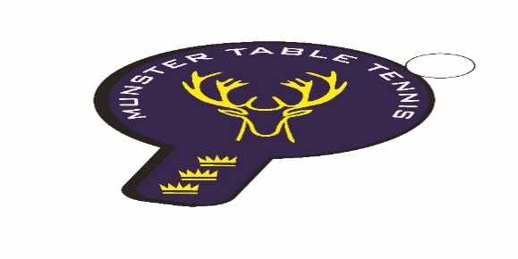
Munster Branch, Irish Table Tennis Association
Annual Report 2022 - 2023 Season
Executive Committee
6 Committee meetings were held during the season. Meetings with external agencies such as Munster Special Olympics, Cork Sports Partnership, Mixed Ability Sports Ireland and Waterford Sports Partnership were held also.
Primary Strategic Themes – Progress Report Phase 1
Participation & sport development
Membership growth – 51 for season 21/22, unchanged for22/23
Gender balance – 20% Female members and 80% Male members in the 2021/22 season – unchanged in the 2022/23 season.
Active Schools growth. Schools Coaching Programme completed in the period Sept - April for Cork City and County schools. 14 new schools targeted – 11 primary and 3 secondary - and a total 454 pupils attended the sessions.
New to table tennis programmes. 4 taster sessions completed with under 12s with Cork Rebel Wheelers. 6 sessions completed with a WIS group with the support of Cork Sports Partnership.
Inclusion. 4 taster sessions completed with under 12s from Cork Rebel Wheelers. 3 special schools included in the Schools Coaching Programme. Inaugural training camp for a Munster Para Squad completed in April. Development of a mixed ability hub in Cork with Beech Hill and Leeside clubs with DAF funding received. Munster continues to contribute up to 50% of the TTI Para Development Squad. Plans are at an advanced stage to send a mixed ability squad to Brighton TT Club, UK in September.
Club Development. Ballincollig TT Club has withdrawn from competitive activity following departure of the club coach in Sept – coaching for 6 weeks provided to the Club in March/April by the Branch to stimulate competitive interest. UCC TT Club is being supported by the Branch and participation by UCC players in Munster TT events has increased this season. Contact established with UL TT Club and the offer of coaching support made but not taken up. Club development in Waterford carried out in Aug/Sept 2022 in conjunction with Waterford Sports Partnership, however the lack of a venue has delayed further development up to May 2023. A further 6 coaching sessions will be provided by the Branch to support WSP re-ignition efforts in 2023 – the club will be based in SETU, Waterford. This season has seen the participation of players from Waterford in Munster TT events and two players have competed at Inter Provincial level this season.

Brilliant Events
Exhibition events. Cork Sports Ability Month Sept 2022 – two “come and try” sessions completed.
Event streaming/recording to include match commentary and interviews provided at the Munster Open in January 2023.
Ranking Events:
16 Oct – South Coast - 65 entries
04 Dec – Beech Hill/Leeside – 68 entries
15 Jan – South Coast – Senior event only - 23 entries
27-29 Jan – Munster Open – 86 entries
19 Feb – Beech Hill/Leeside – 35 entries
12 Mar – Beech Hill/Leeside – 42 entries
Liaison carried out with Munster Technology University in Cork in Jan/Feb 2023 with a view to the suitability of their new indoor arena as a permanent home for the Munster Open. Provisional booking of the MTU Indoor Arena for January 13/14 2024 has been made.
Building Profile
Social Media & Marketing. Branch Committee appointed a digital marketing officer (volunteer) - website development is the priority for the 2022/23 season. This person resigned in January 23 . The website is being overhauled by an external agency. The Branch is expecting to have an additional member of the Committee in September who will assist with social media.
Sponsorship. No success with regard to a number of approaches to companies for sponsorship of the Munster Open. Much work to be done in this specific area.
Event streaming. Munster Open live streamed/recorded as outlined above.
Organisational Strength & Capacity
Safeguarding. Clubs have not responded to questionnaire sent by the Branch Committee, so situation at club level is unclear. Current Branch Chair is the Safeguarding Officer for Munster TT and remains fully qualified.
Regional Development Officer. No progress here.
Income streams: sponsorship. No progress here
Gender Balance in Committee. No progress for current season, however the Branch expects to appoint a female ex-officio member to the Committee in September.
Coach/Official/Volunteer Development. One new L 1 coach qualified at Leeside TTC, otherwise the number of active volunteers at club level has declined. The Munster Branch Committee has lost two members in the season. Plans are at an advanced stage with respect to holding a Level 1 coaching course in early September in Cork.

Executive Committee for 2023/24 Season:
Eoin Kelly – Chair, A/Sec & Safeguarding Officer
Joe Kelleher – Treasurer
Ben Haughton – Performance
Philip Shaw – Participation
Proinsias Collins – Para & Inclusion
Thuy Linh Cashman (ex officio) – WIS & social media

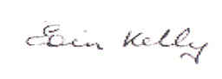
Eoin Kelly, Chair, Munster Branch Executive Committee

