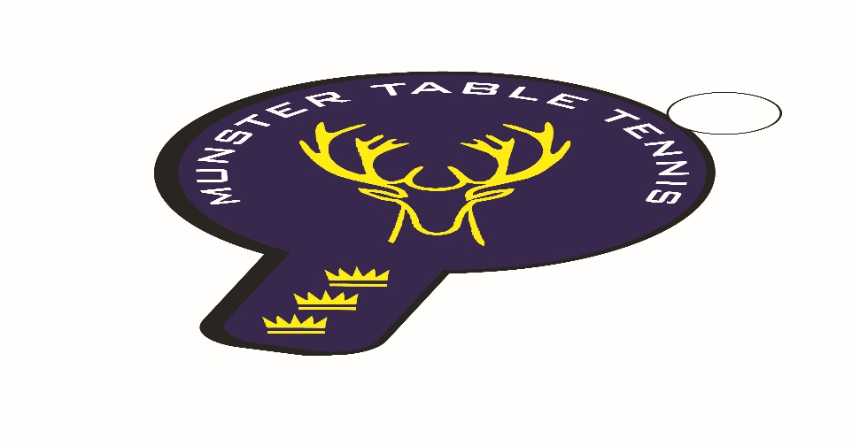
Knocknaheeny Ranking Event 12 March 2023
Competition Report
A total of 49 entries were received for the third Knocknaheeny event, which was an increase of 14 from our previous event in February also in Knocknaheeny – most notably from the UCC club with 8 entries. Once again we had players from 3 counties – Cork, Kerry and Waterford – with 6 different clubs contributing players. The following categories were offered – U/14, Veterans and Senior Divisions 1 and 2. Division 2 was offered as a mixed ability competition in line with the Branch’s policy on offering inclusive playing experiences where possible.
Overall, it was a good day for the Kerry clubs. The player of the tournament had to be Anthony Redmond, Killarney, with wins in both the Veterans and Senior Division 1, albeit the latter came about as a result of the withdrawal of finalist Scott Shellard, South Coast, due to injury with the scores tied at one set each. Senior Division 2 was won by Marius Chmielswski, also from Killarney, beating Joseph Claro, from Tralee in the final. Beech Hill’s evergreen Philip Shaw was runner up in the Veterans, while South Coast’s Atilla Magyar Junior beat his club mate Florian Lotkowski in the Under 14 competition – this was Atilla’s second successive victory at this level this season, so well done to him. Also, great to see Samanta Puskinskas making her debut in the Under 14 event and winning the Girl’s competition. A special mention to Para players, Annie O’Callaghan, UCC, and Aoife Kelly, Beech Hill, who contested the Senior Division 2 Plate final.
The results are as follows:
U/14
1st: Attilla Magyar Junior – South Coast
2nd: Florian Lotkowski – South Coast
Joint 3rd^{d}: Conal Conroy – Leeside & Theo Farkas – Unattached
Veterans
1st: Anthony Redmond – Killarney
2nd: Philip Shaw – Beech Hill
Joint 3rd: Nikolai Genov – Beech Hill & Catherine Morrissey – Waterford
Senior Division 1
Ist: Anthony Redmond – Killarney
2nd: Scott Shellard – South Coast
Joint 3rd: Paddy Vaughan – UCC & Radoslaw Zbik - Killarney
Senior Division 2
1st: Marius Chmielswski - Killarney
2nd: Joseph Claro - Tralee
Joint 3rd: Kasper Darnowski – Leeside & Ronan Geary - Waterford

