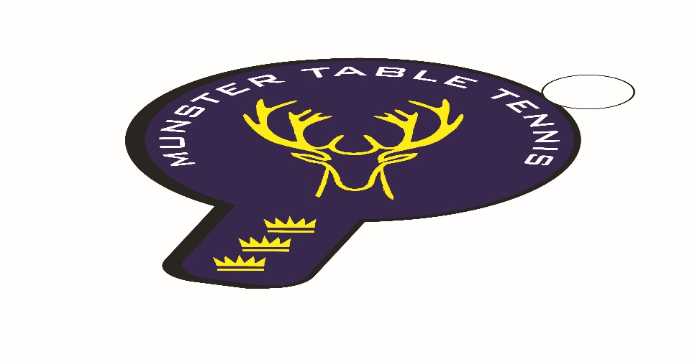
Knocknaheeny Ranking Event 19 February 2023
Competition Report
A total of 35 entries were received for the second Knocknaheeny event, which was a decrease of 17 from our previous event in Kinsale – most notably in the U/14 and Veterans categories – and our smallest complete event so far in the season. We had players from 3 counties – Cork, Kerry and Waterford – with 6 different clubs contributing players. The following categories were offered – U/14, Veterans and Senior Divisions 1 and 2. Division 2 was offered as a mixed ability competition in line with the Branch’s policy on offering inclusive playing experiences where possible.
The rivalry between Philip Shaw of Beech Hill and Sean Loughnane of South Coast continued in the Senior Division 1 event with Philip winning the final on a 3 sets to 1 scoreline. Philip did not have it his own way in the Vets, as we are accustomed to, when meeting with the evergreen Anthony Redmond, of Killarney, in the final where Anthony prevailed on a 3 sets to 1 scoreline. The Senior Division 2 category event was run by Chetan Rai from UCC with a 3 sets to 1 victory over Jack O’Brien from Beech Hill, who was competing is his first ranking event for a number of years. Finally the Under 14 title went to Attilla Magyar Junior from South Coast who finished ahead of Sean Buckley of Leeside, who was returning to table tennis after a break of 4 months. So, honours were shared out evenly among the clubs. The results are as follows:
U/14
1st: Attilla Magyar Junior – South Coast
2nd: Sean Buckley – Leeside
3rd^{d}: Conal Conroy – Leeside
4th: Florian Lotkowski – South Coast
Veterans
1st: Anthony Redmond – Killarney
2nd: Philip Shaw – Beech Hill
3rd: Nikolai Genov – Beech Hill
4th: Margie Hadden – Beech Hill
Senior Division 1
Ist: Philip Shaw – Beech Hill
2nd: Sean Loughnane – South Coast
Joint 3rd: Anthony Redmond – Killarney & Conor O’Sullivan – South Coast
Senior Division 2
1st: Chetan Rai – UCC
2nd: Jack O’Brien – Beech Hill
Joint 3rd: Caoimhe Deane – Leeside & Ronan Geary - Waterford

