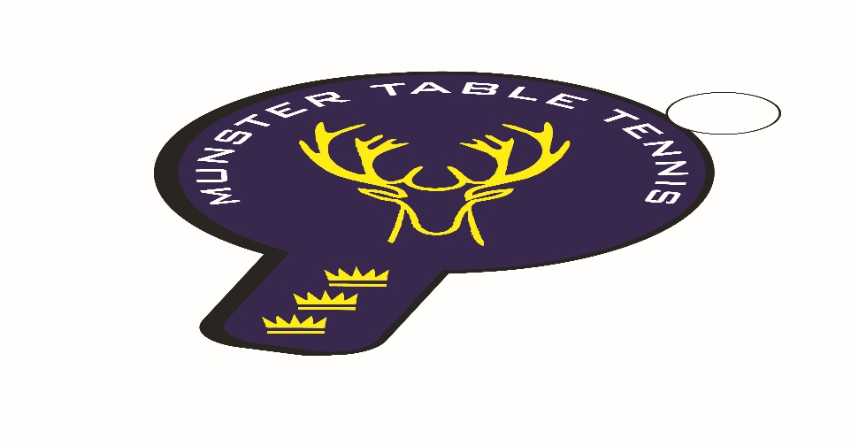
Kinsale Ranking Event 15 January 2023
Competition Report

A total of 20 players competed at the Kinsale ranking event (Munster Branch event no 3) which was a restricted event for senior players only. Notable was the failure of 5 players, who failed to show for registration, to notify the Branch of their non-attendance in advance or at any subsequent time. The Branch Executive Committee takes a dim view of such a failure of etiquette and will be following up with the individuals in due course. Needless to say this failure led to a significant disruption to the start of the competition as the draw had to be re done there and then. Players were ranked in two divisions in accordance with current rankings. It turned out to be a great day for the Loughnane brothers with Sean winning the Senior 1 Division and Ben finishing in third place. Senior 2 Division was won by a complete new-comer to Munster Table Tennis – U/14 aged Ronan Geary from Waterford – with an assured performance throughout the afternoon. We expect great things from Ronan in the future! The Kerry clubs were well represented by Joseph Claro who finished runner up in the same division. The results are as follows:

Senior Division 1
Ist: Sean Loughnane – South Coast
2nd: Paddy Vaughan – UCC
3rd: Ben Loughnane – South Coast
4th: Philip Shaw – Beech Hill

Senior Division 2
1st: Ronan Geary - Waterford
2nd: Joseph Claro – Tralee
Joint 3rd: Caoimhe Deane – Leeside
Margie Hadden – Beech Hill

