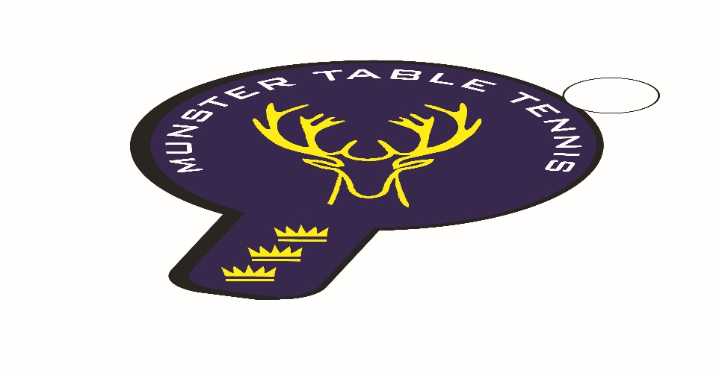
Knocknaheeney Ranking Event 04 December 2022
Competition Report

A total of 60 players competed at the Knocknaheeney event, which was an increase of 8 on our Kinsale event. It was notable that we had players from 3 counties – Cork, Kerry and Waterford – with 7 different clubs contributing players. A big welcome to players from UCC! The following categories were offered – U/14, Veterans and Senior Divisions 1, 2 and 3.
Shock and horror – Philip Shaw did not win the Senior Division 1 event! That achievement fell to Ben Loughnane of South Coast, who beat Philip at the sixth time of asking in the final to win his first senior competition. Many congrats Ben! Both Senior 1 semi-finals went to 5 sets and there was very little between Philip, Chetan Rai (UCC) in one semi-final, and Ben and Nickolay Genov (Beech Hill) in the other. Philip did retain his Vets title, and, at this stage, his rival vets are wondering if there is any legal means left to stop him! Beech Hill edged the inter club honours with wins in two events. The results are as follows (apologies but full details of names were not received for some of the entries:

U/14
1st: Daragh Crowley – Leeside
2nd: Joshua Murphy – South Coast
Joint 3rd: Attila Jnr - South Coast & Julia Dniedzic – Killarney

U/14 Plate Competition
1st: Callum Bolton – South Coast
2nd: Fintan Touhy – South Coast

Girls U/14
1st: Julia Dniedzic – Killarney
2nd: Alvina Khochan – Waterford

Veterans
1st: Philip Shaw – Beech Hill
2nd: Colm Carew – Waterford
Joint 3rd: Nikolai Genov – Beech Hill & Gary Mahony – Leeside

Senior Division 1
Ist: Ben Loughnane – South Coast
2nd: Philip Shaw – Beech Hill
Joint 3rd: Chetan Rai – UCC and Nickolay Genov – Beech Hill

Senior Division 2
1st: Mayank Srivvastava – UCC
2nd: Robert Metcalf – Leeside
3rd: Joseph Claro – Tralee and Damien Chuy - UCC

Senior Division 3
1st: Finbarr Medina – Beech Hill
2nd : Laura O’Keeffe - UCC
Joint 3rd: Caoimhe Deane & Darragh Ruddy - Leeside

